
ADDENDUM

January 20, 2025

RE: CITY OF MOBILE BID #5928 FOR PERATON SPARTAN EOD ROBOT

Please consider the following to be Addendum to City of Mobile Bid #5928 for Peraton Spartan EOD Robot.

DUE TO FORTHCOMING INCLEMENT WEATHER, THE BID OPENING DATE HAS BEEN CHANGED

FROM

12:01 PM, Thursday, January 23, 2025

TO

12:01 PM, Friday, January 24, 2025

Thank you for your consideration in this matter.
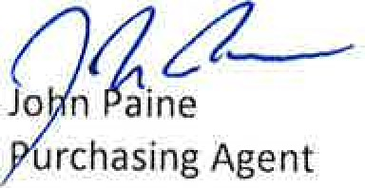
City
of
Mobile
JP/EN

City of Mobile Post Office 1827 Mobile, 36688-1827

